2018 – 2019 COMPETITIVE TRYOUTS

Boys  Born In  2008 - 2003  Armada Competitive Teams | Girls  Born In  2008 - 2005  Armada Competitive Teams | Boys/Girls  Born In  2008 - 2005  Armada Competitive Teams | Girls/Boys  Born In  2012 - 2008  Boys & Girls Academy
May 2  Gamble Rogers Middle School  St Augustine, FL 32137 | May 2  Gamble Rogers Middle School  St Augustine, FL 32137 | May 7  MAKE UP DATE  Only attend if unable to attend MAY 2  Gamble Rogers Middle School  St Augustine, FL 32137 | May 15  Gamble Rogers Middle School  St Augustine, FL 32137
5:30-7:00pm:  2008 Boys  2007 Boys  7:15-8:45pm:  2006 Boys  2005 Boys  2004 Boys  2003 Boys | 5:30-7:00pm:  2008 Girls  2007 Girls  2006 Girls  2005 Girls | 5:30-7:00pm:  All Age Groups | 5:30-6:15pm:  2012 Boys/Girls  2011 Boys/Girls  6:30-7:30pm:  2010 Boys/Girls  2009 Boys/Girls  2008 Boys/Girls  2007 Boys  *Players born in 2007 & 2008 are encouraged to attend both Armada tryouts & Academy tryouts.
Pre-Tryout Registration REQUIRED  Check-in will start one hour before your session | Pre-Tryout Registration REQUIRED  Check-in will start one hour before your session | Pre-Tryout Registration REQUIRED  Check-in will start one hour before session | Pre-Tryout Registration REQUIRED  Check-in will start one hour before session

Questions? Email: info@staugustinearmada.com
___________________________________________________________________

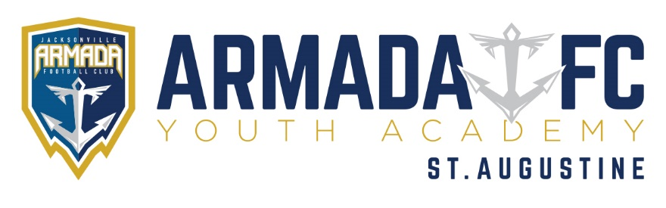

PRE-TRYOUT PROCEDURE
- Players must Pre-Register for tryouts. To pre-register go to www.ancientcitysoccer.com.
- Player Check-In will start one hour before your tryout session:
  - You will verify all player and parent contact information is correct
  - You will receive your tryout number
  - You will have a photo taken for your player pass
  - Staff will then send you to the correct field
- One Parent/Guardian is required to attend tryouts. If your son/daughter is selected for a team, you will need to be present to accept their position on the team.
POST-TRYOUT PROCEDURE
- At the end of each night of tryouts, players will be grouped into 3 distinct groups:
  - Selected – You have been selected for the team this year.
  - Need 2nd Evaluation – Coaching staff would like to see you again before making a decision.
  - Not-Selected – You were not selected for the team this year.
- Upon being selected for a competitive team, you will be directed by your coach to the on-site registration area to complete your team acceptance and player commitment form.
- You will then receive an email with further instructions and details to complete your registration for the 2018-2019 seasons.
______________________________________________________________________

